Name:

Air Pollution
Air pollution is the contamination of Earth’s atmosphere with pollutants. Pollutants are substances that can harm the environment. Factories, cars and trucks release air pollutants. Some of these substances are released when fossil fuels are burned. These substances can be toxic. Other substances are not toxic but have harmful effects. Air pollution can damage Earth’s ecosystems and harm animals around the globe.
Burning Fossil Fuels
Fossil fuels are an important source of energy for humans. Fossil fuels are fuels that formed from the remains of organisms that lived millions of years ago. Oil, natural gas and coal are types of fossil fuels. Fossil fuels are nonrenewable resources. It takes a very long time for fossil fuels to form which is why we call them nonrenewable. They cannot renew themselves at the same rate we use them. We burn fossil fuels to produce energy. Factories, cars and many electrical power- generating plants burn fossil fuels. This releases carbon dioxide and gases into the air. Some of the gases contain sulfur and nitrogen, which harm the environment.
Carbon dioxide is an important gas. Plants use carbon dioxide in photosynthesis to make food and oxygen. However, excessive amount of carbon dioxide can alter ecosystems. Carbon dioxide is a greenhouse gas. Greenhouse gases trap heat from the sun to keep Earth warm. There is concern that too much carbon dioxide and other greenhouse gases can significantly warm Earth and change global climate patterns. This is called global warming. Global warming will be discussed more in a different activity.
Sulfur and nitrogen containing gases can combine with moisture in the atmosphere. This forms acid rain. Acid rain is more acidic than normal precipitation. It can damage plants and runoff into lakes and streams. If acid rain runs-off into lakes and streams, it can lower the pH of the water. This can kill fish, plants and other aquatic organisms.

Chlorofluorocarbons (CFCs)
Air Pollution Continued

Some products we use release harmful chemicals into the air. These chemicals are called chlorofluorocarbons or CFCs. CFCs are compounds that destroy ozone in the upper atmosphere. Ozone is a gas that forms a protective layer in the atmosphere. The ozone layer reflects harmful UV light from the sun. CFCs destroy ozone and create holes in the ozone layer. This is called ozone depletion. You will learn more about ozone depletion in a different activity.
CFCs are used to propel substances out of aerosol cans and as coolants in refrigerators and air conditioners. CFC’s are also used to manufacture plastic foam. CFCs used to be found in fire extinguishers because they were a great fire-fighting agent. Because we know the damage CFC’s cause, they are continuously being replaced by alternative substances that do not harm the ozone layer.
Smog
Air pollutants are produced by automobile exhaust and by factories. Weather conditions can trap these gases in an area close to ground. The pollutants react with sunlight to form a “smoky fog.” It looks like a grey or brown haze. This is called smog. Smog is a type of air pollution that can linger for hours or days. It can be very dangerous, especially to people with respiratory illnesses. People with respiratory illnesses are very sensitive to air pollution when inhaled.
Smog is common in urban areas. There is a high concentration of cars, trucks and factories, which contribute to the pollution that causes smog. Smog is usually a human-induced effect. However, erupting volcanoes can sometime create a “natural” smog effect.
How do we stop air pollution?
Scientists and engineers are creating better ways to filter air pollutants. They create filters that trap toxic gases so they do not enter the atmosphere. The filters are called scrubbers. They are also removing air pollutants, like CFCs, from products that harm the environment. They replace the CFCs with other substance that do pollute the air. Another way to reduce air pollution is reduce our use of fossil fuels. We can do this by developing more efficient automobiles and developing cleaner sources of energy.

Acid Rain
Acid rain is precipitation that is more acidic than normal precipitation. Acid rain is formed when air pollution combines with moisture in the atmosphere. When it falls to ground, it damages plants and animals. Acid rain can runoff into lakes and rivers and disrupt aquatic ecosystems as well.
Acid rain forms when fossil fuels burn. Burning fossil fuels released sulfur and nitrogen into the air. These compounds combine with water vapor in the air to form acidic water vapor. The acidic water vapor condenses to form acid rain clouds.
The formation of acid rain clouds usually occurs over urban and industrial cities where fossil fuels are burned to create energy. However, acid rain does not usually fall in the same location it formed. Acid rain clouds travel with wind currents. Often, the acid rain clouds travel to more rural areas. Acid rain then falls to ground and damages ecosystems.
Acid rain can be as acidic as lemon juice. The more acidic the rain, the more damage it will cause to plants and animals. Acid rain damages the structure of plants and disrupts the way plants function. Acid rain can make plants more susceptible to disease or attack by insects as well.
Acid rain runs off into lakes and streams. This is harmful to fish, aquatic plants and other organisms. Acid rain is deadly to algae. Without algae, water looks crystal clear and clean. However, algae often form the base of aquatic food chains. Food chains are completely disrupted when algae is no longer present. Unfortunately, some lakes have become so acidic that nothing can live in them.
Engineers have developed filters to reduce nitrogen and sulfur from gases released by fossil fuel burning factories and power plants. These filters are called scrubbers. However, acid rain is still a concern. Scientists and engineers are looking for better ways to filter nitrogen and sulfur. They are also looking for alternatives to fossil fuels that do not produce pollutants that cause acid rain.

Name:

Global Warming
Some pollutants can cause global atmospheric changes. These changes can threaten habitats and the organisms and live in them all around the world. A major concern is global climate change. Life on Earth depends on certain climate conditions. We depend on certain temperatures and rainfall amounts. If climate changes, ecosystems will be altered and organisms will be affected.
Since the late 19th century, the average global temperature has risen almost 2 degrees Fahrenheit. Scientists describe the increase in Earth’s average temperature as global warming. There is strong evidence to support global warming. Let’s investigate more about global warming and how it can affect the Earth.
Greenhouse Effect
It is important for Earth to be warm. If Earth is not warm enough, life could not exist on Earth as it does today. Earth is warm because of the greenhouse effect. The greenhouse effect is the process by which the sun warms the Earth. Sunlight passes through gases in the atmosphere. Some the sun’s radiation reaches Earth’s surface. Some of the sun’s radiation is reflected off Earth’s atmosphere or surface back into space. Gases, such as carbon dioxide and water vapor, in the atmosphere, absorb some of the sunlight. These gases are called greenhouse gases. Greenhouse gases absorb infrared radiation or heat from the sun.
Human Contribution to Greenhouse Gases
In recent years, the amount of greenhouse gases, specifically carbon dioxide, has increased. More greenhouse gases means more of the sun’s heat is trapped in the atmosphere. The result is that Earth’s average temperature is rising.
Carbon dioxide is released when fossil fuels are burned. Power plants and industries burn fossil fuels. Trucks and cars burn fossil fuels as well. Deforestation increases carbon dioxide levels as well. Trees absorb carbon dioxide and with fewer trees, less carbon dioxide is removed from the atmosphere.

Why are we concerned?
Global Warming Continued

An increase in global temperature, even just a few degrees, can significantly alter climate patterns. Changes in climate patterns can modify Earth’s ecosystems. This is a concern because organisms depend on certain temperatures and weather patterns. If climate changes, organisms may not be able to survive in their existing ecosystems.
Increase in global temperatures could cause melting of the ice caps at the North and South Pole. Scientists are concerned that melting of the ice caps could cause sea levels to rise and flood costal areas. Other scientists are concerned that melting of the ice caps could accelerate the increase in global temperatures. Ice caps reflect sunlight back into space. Without ice caps, Earth's oceans would absorb large amount of sunlight.
What can we do about global warming?
Finding and using energy sources that do not add excess carbon dioxide or other pollutants to the atmosphere is one way to prevent global warming. It is also important to curb deforestation and grow more trees. Trees and other plants remove carbon dioxide from the air through the process of photosynthesis.
Using energy more efficiently will also reduce carbon dioxide emissions. It will also reduce production of other pollutants. Reusing and recycling products and resources can help stop global warming. Many products are made in factories that burn fossil fuels for energy. Reusing and recycling these products means less fossil fuel is burned to produce new products. This further decreases greenhouse gases released into the atmosphere.
All of these actions will positively impact the Earth. Whether you agree or disagree with global warming, it’s important to take actions that use Earth’s resources sensibly, responsibly and efficiently. This will ensure that Earth is the same home to future generations of humans and other species.
Many people debate the facts and evidence of global warming. However, most people will not dispute that it is important to wisely manage Earth’s resources and to limit the pollutants we produce. You will learn more about how to wisely manage resource and protect the environment in different activities.

Ozone Depletion
Ozone depletion is a global atmospheric problem. High in the atmosphere is a layer of gas called ozone. It forms the ozone layer. The ozone layer protects Earth from some of the sun’s radiation. It shield Earth from harmful ultraviolet (UV) radiation. UV light can cause sunburns and skin cancer.
Unfortunately, some air pollutants destroy the ozone layer. This is called ozone depletion. Pollutants called CFCs or chlorofluorocarbons cause ozone depletion. CFCs have been used as coolants in refrigerators and air conditioners. They have also been used as a propellant in aerosol cans and fire extinguishers and in the production of plastic foams.
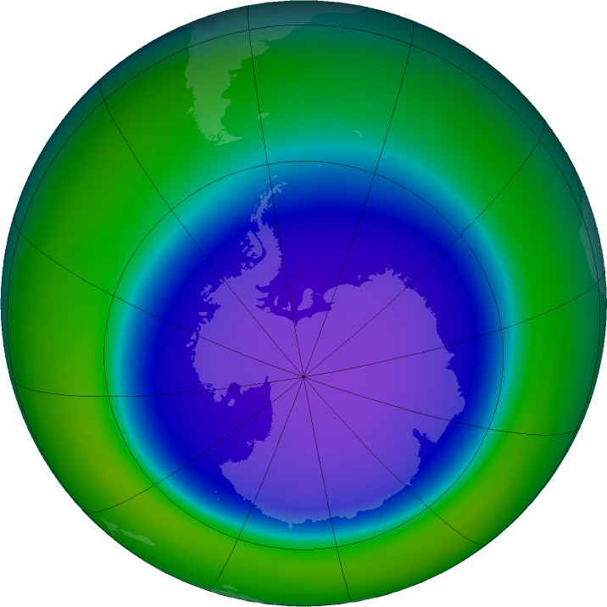
CFCs rise into the upper layers of the atmosphere. They cause ozone to break down which creates holes in the ozone layer. Because of atmospheric winds and other factors, holes in the ozone layer are most noticeable at North and South Pole. CFCs get trapped in “polar vortex winds” and break down the ozone layer over the poles. The most prominent hole is at the South Pole. It is larger because it is colder at the South Pole. Colder temperatures promote further degradation of the ozone layer.

Scientists are concerned about ozone depletion because the ozone layer protects us from harmful radiation. They are concerned that increased UV light will cause more skin cancer cases. Scientists are also concerned that increased UV light will destroy algae in the ocean. This would disrupt food chains and reduce the amount of oxygen produced on Earth.

Courtesy NASA, Oct 2015

Many alternatives to CFCs have been developed. They have replaced CFCs as propellants and coolants. International agreements have been made to reduce CFC emissions as well. Unfortunately, CFCs linger in the atmosphere for years and their effects are not yet over.

Air Pollution Graphic Organizer

The main idea of the reading is…
New terms and vocabulary words:

Air Pollution
In summary… The most
important details:

Land and Soil Contamination

The most important details:
Land and Soil Contamination

Acid Rain Graphic Organizer

The main idea of the reading is…
New terms and vocabulary words:

Acid Rain
In summary… The most
important details:

Global Warming Graphic Organizer

The main idea of the reading is…
New terms and vocabulary words:

In summary…
Global Warming

The most important details:

Ozone Depletion Graphic Organizer

The main idea of the reading is…
New terms and vocabulary words:

In summary…
Ozone Depletion

The most important details:

