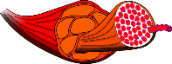
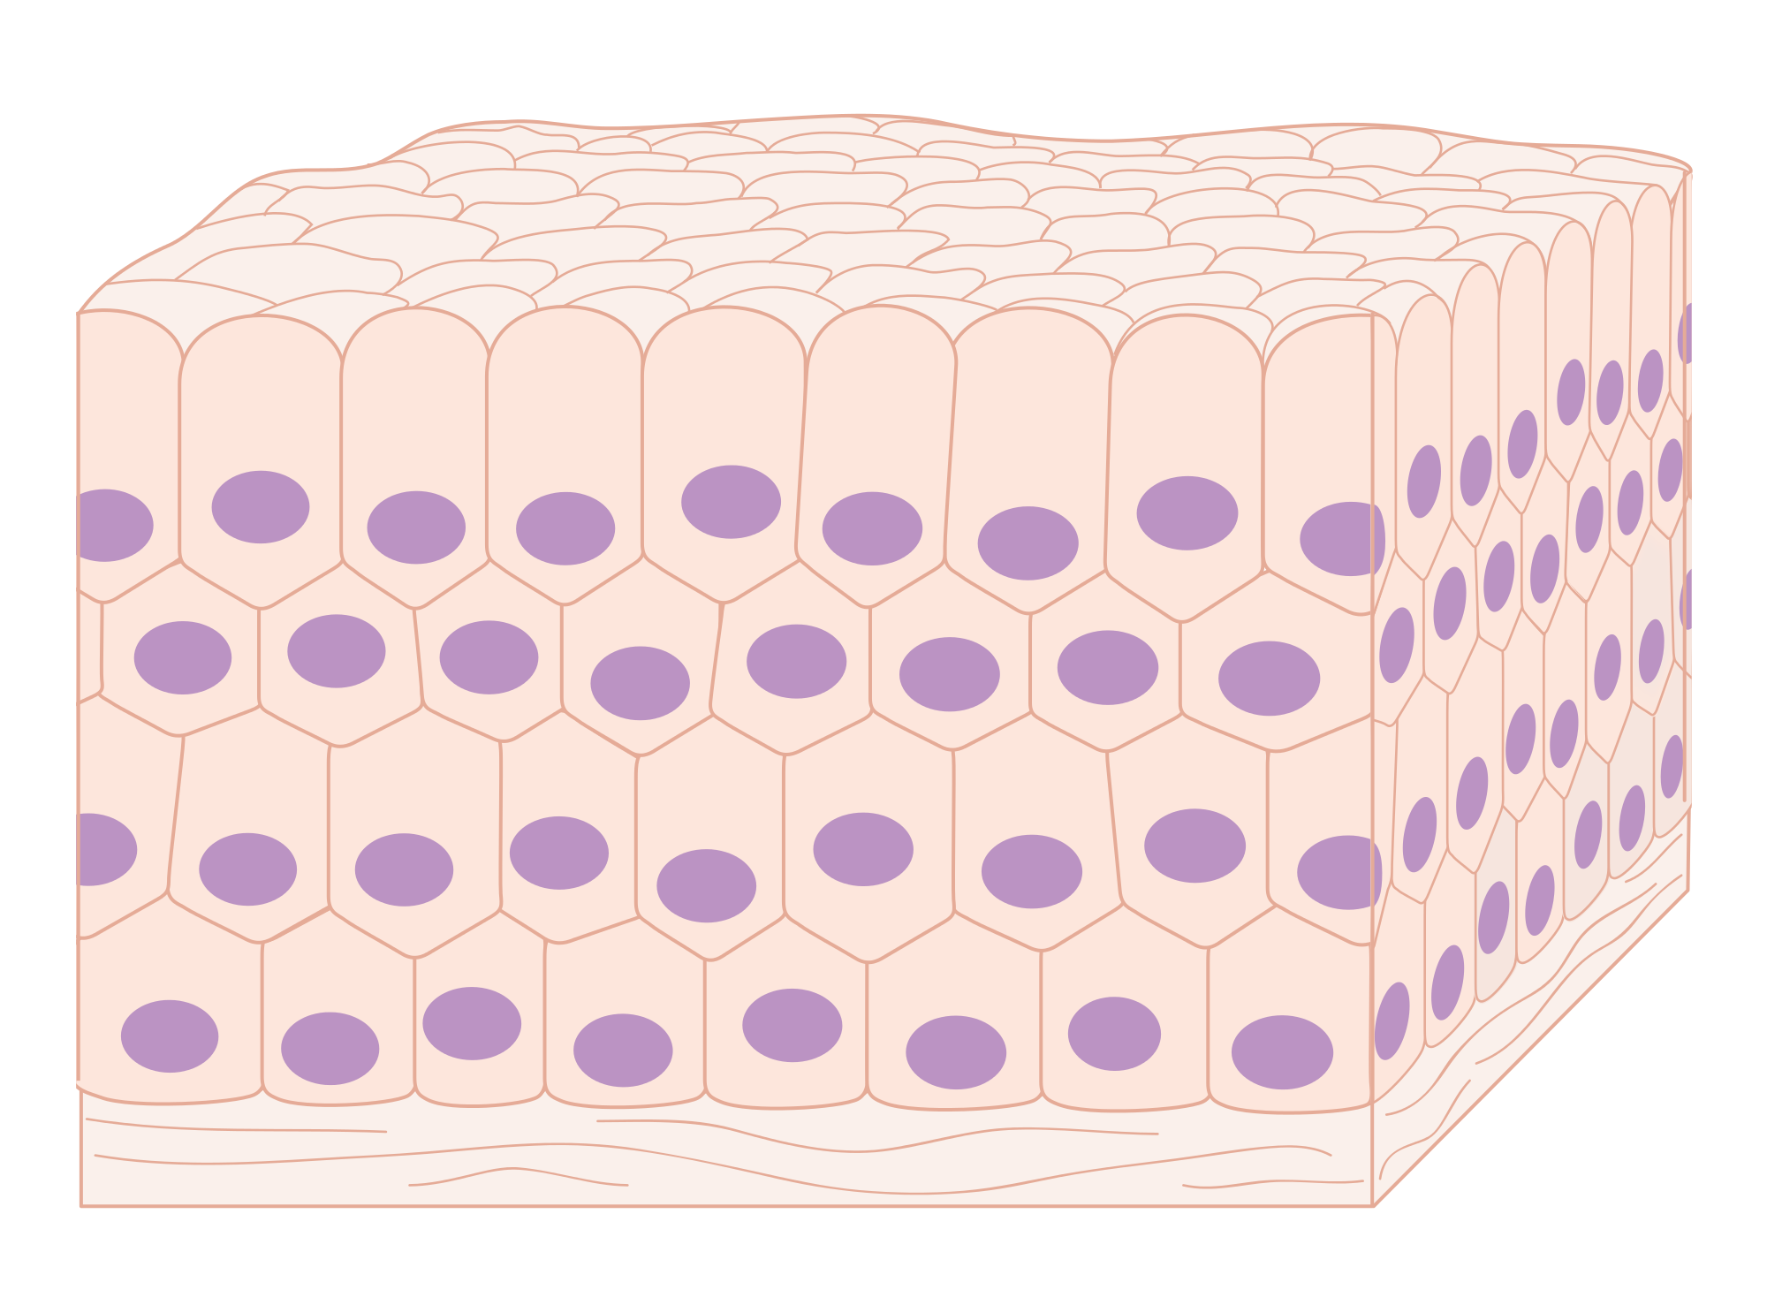
Name: Date:
Station 2- The Nucleus
Function of the nucleus:

. Structures the nucleus depends on:

Station 4- Cells to Tissues
How do organelles make up cells?

. How do cells make tissues?
. Provide examples of tissues: 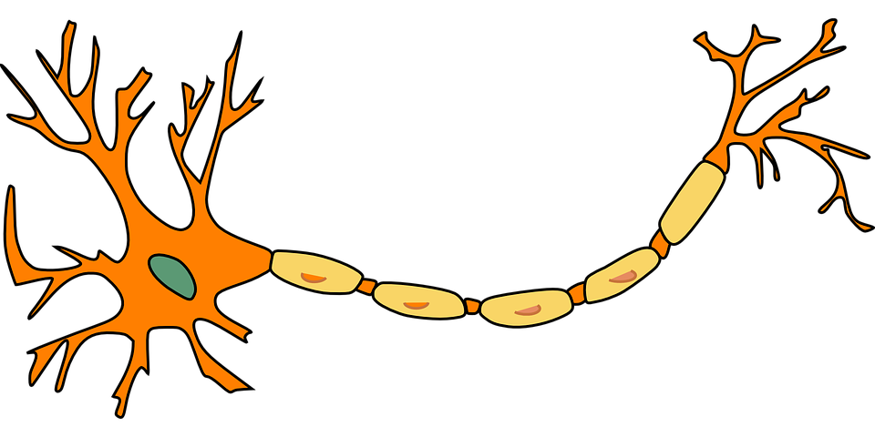

Are all tissues the same?

.
PROKARYOTE | EUKARYOTE

ce l l s
Station 1- Prokaryote or Eukaryote?
Explain how you can tell by looking at an illustration if a cell is prokaryotic or eukaryotic?

.

Station 3- Prokaryotes or Eukaryotes?

Among your eukaryotic organisms, circle the ones with animal cells and put a rectangle around the ones with plant cells. Leave all others blank.
Station 5- Ribosomes
Function:

.
- Station 6- What is the function of the chloroplast?

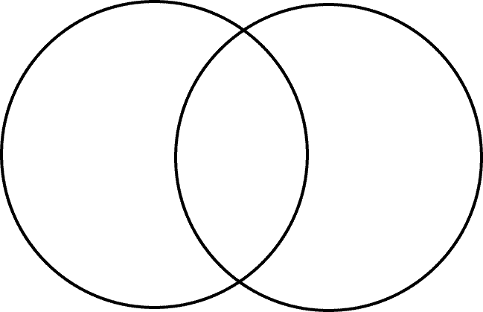
Station 13- Cell Membrane
The function of the cell membrane is
____________________

_________________________________. 2-3 reasons why it’s important:
- __________________________________ __________________________________

- __________________________________
__________________________________

- __________________________________
__________________________________
Eukaryote
Prokaryote
Station 12- Prokaryotic vs. Eukaryotic Cells. Use the Venn Diagram to Complete the task.

Station 15- MYSTERY CELL
What type of cell do you think you are viewing under the microscope? Explain your reasoning:
____________________________________________________________________________
___________________________________________________________________________________
___________________________________________________________________________________
Station 16 Cell Analogy- Compare a cell to a factory
Determine which organelles are best represented by each type of factory component
Station 14 What is the cytoplasm?
__________________________________________
__________________________________________
Factory Component | Description/Job | Organelle most closely associated:
Main office | Controls and manages the activities at the factory, initiates production and provides the blueprints for the products.
Packaging and Shipping | Packs products and sends them out for distribution.
Generator | Produces the electricity required to run the factory.
Doors to the outside with buzzer to only let approved personnel and products into the factory. | Determines what can leave the factory and what can enter the factory.
Recycle center | Breaks down old or damaged products to use the parts.

Station 8- BRAINSTORM What do you think would happen if the nucleus was removed from your cells? List some ideas:

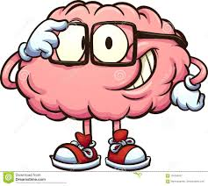
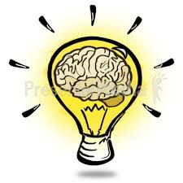
Station 11- Plant Cells vs. Animal Cells Using your answers for Station #10 above, explain why animal cells do NOT need or why they are different in organelles that are found in plant cells
Animal cells do not need
because
____________________________
_______________________

Animal cells do not need
because
_____________________
.
Animal cells do not need
because __________
____________________________
Station 10 - Plant Cells vs. Animal Cells 3 organelles found in PLANT cells, but absent or different in plant cells

Station 9- Tay-Sachs Disease
What malfunctioned organelle do you think causes Tay-Sachs Disease? List 2-3 reasons why:
- ________________________________________________________________________________________________
- ________________________________________________________________________________________________

Station 7- Leigh Disease
What malfunctioned organelle do you think causes Leigh Disease? List 2-3 reasons why:

- _________________________________________________________________________________

